Lab Activity 03 Part 2 Worksheet

Take screenshots and answer the questions using the instructions in the procedure document.

1. Disk Cleanup Maintenance Tool and Question
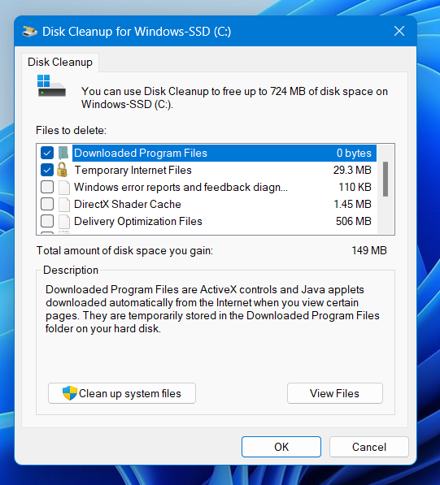
Why would you use the disk cleanup tool?
- By using it, we can clean junk files and improve the performance of our laptops. Also, We can clear space for our other files.

2. Optimize Drives Screenshot and Question
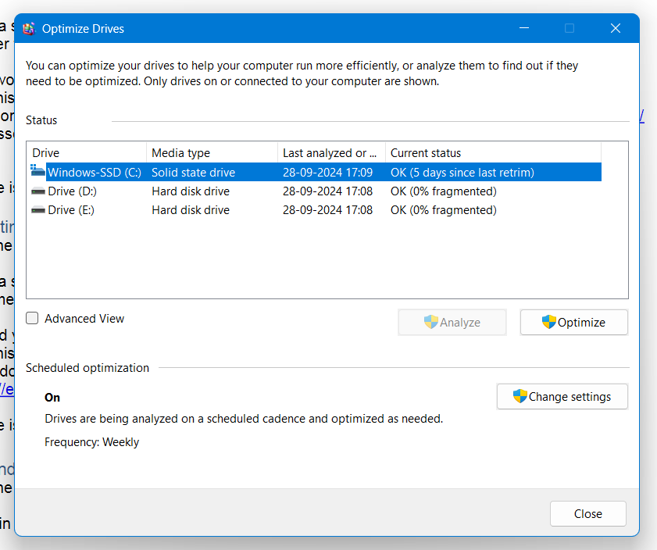
Should you ever defragment a solid-state drive?
- No, we should not.

3. Windows Backup Utility Screenshot and Question
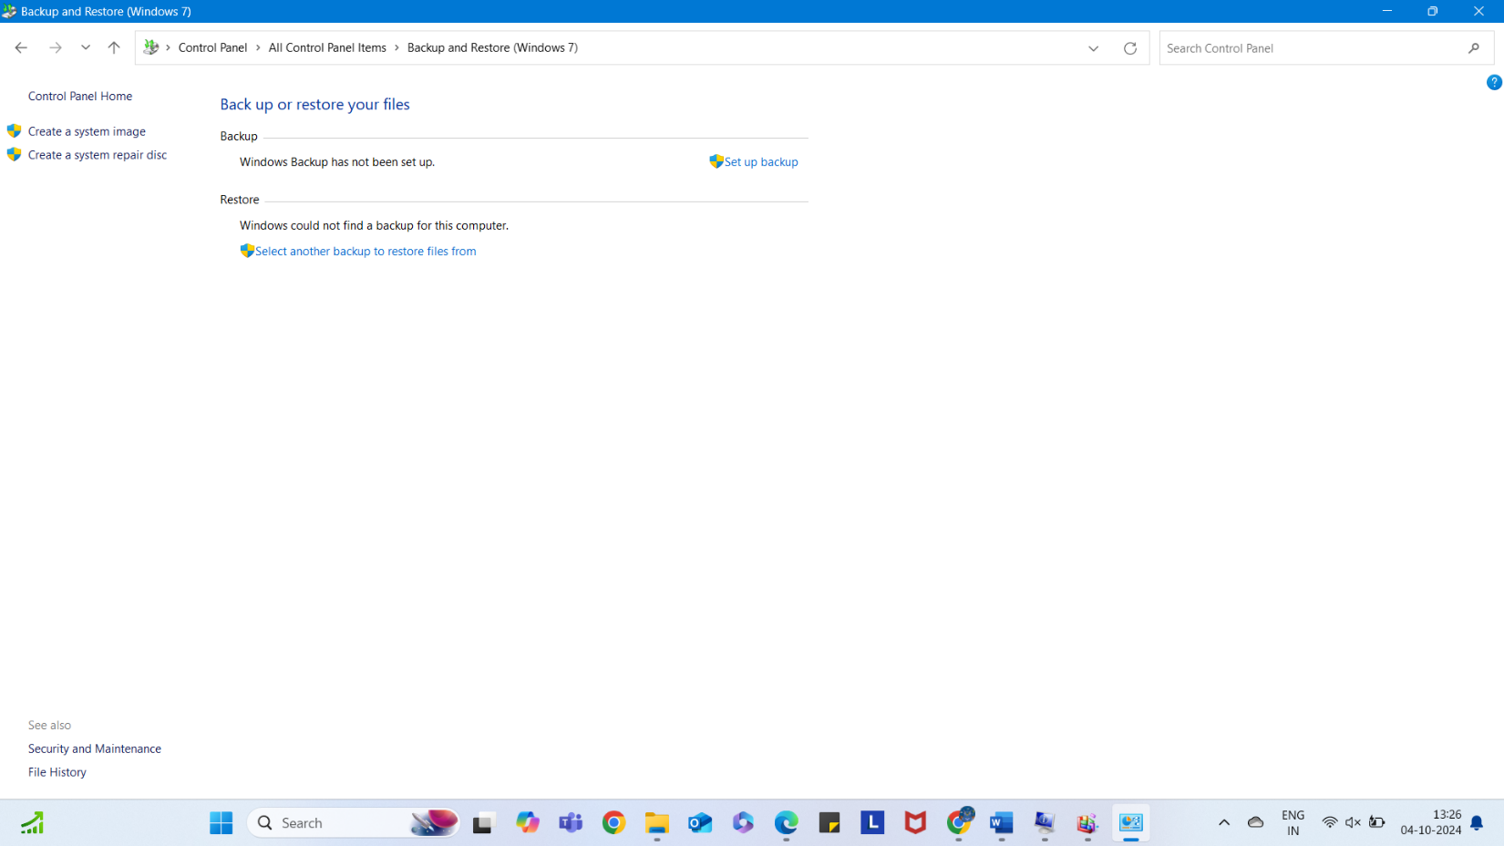
Why should you back up the data on your computer often?
- Due to these five reasons:
- 1. To make recovery quicker after a hack
- 2. To reduce the risk of software/hardware failure
- 3. To reduce the recovery effort of lost or stolen devices
- 4. To maintain good computer hygiene
- 5. Because it’s simply a good practice

4. Command Prompt and ping, ipconfig /release, ipconfig /renew, ipconfig /flushdns
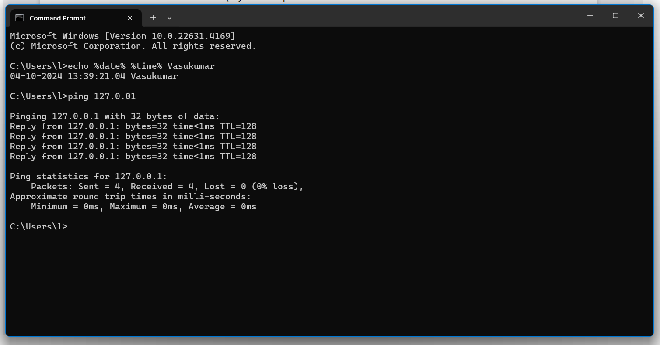

What does ipconfig /? report for:
/release - Release the IPv4 address for the specified adapter.
/renew - Renew the IPv4 address for the specified adapter.
/flushdns - Purges the DNS Resolver cache.

5. Command Prompt and net start spooler, net stop spooler
